# MINI PROJECT OF “C” PROGRAM

PRANAV ARJITH SANKAR.R EWAN ULYSSES P.F

RA2111003010983 RA2111003010982

#include<stdio.h>

#include<conio.h>

void main()

{

int a,b,c,p,t=0;

here: printf("Movie List\n Select any one\n1-Beast\n2=Annathe\n3-theri\n4-natpethunai");

scanf("%d",&a);

if(a==1)

{

printf("ENter the number of tickets you need\n");

scanf("%d",&b);

p=b*200;

t=t+p;

printf("Ticket price = %d\n",p);

printf("Do you need any other movie ticket?\n1-yes\n2-no");

scanf("%d",&c);

if(c==1)

{

goto here;

}

else

{

printf("Total amount to pay = %d",t);

}

}

else if(a==2)

{

printf("Enter the number of tickets you need\n");

scanf("%d",&b);

p=b*300;

t=t+p;

printf("total amount to pay = %d",p);

printf("Do you need any other movie ticket?\n1-yes\n2-no");

scanf("%d",&c);

if(c==1)

{

goto here;

}

else

{

printf("Total amount to pay = %d",t);

}

}

else if(a==3)

{

printf("Enter the number of tickets you need\n");

scanf("%d",&b);

p=b*100;

t=t+p;

printf("total amount to pay = %d",p);

printf("Do you need any other movie ticket?\n1-yes\n2-no");

scanf("%d",&c);

if(c==1)

{

goto here;

}

else

{

printf("Total amount to pay = %d",t);

}

}

else

{

printf("Enter the number of tickets you need\n");

scanf("%d",&b);

p=b*200;

t=t+p;

printf("total amount to pay = %d",p);

printf("Do you need any other movie ticket?\n1-yes\n2-no");

scanf("%d",&c);

if(c==1)

{

goto here;

}

else

{

printf("Total amount to pay = %d",t);

}

}

}

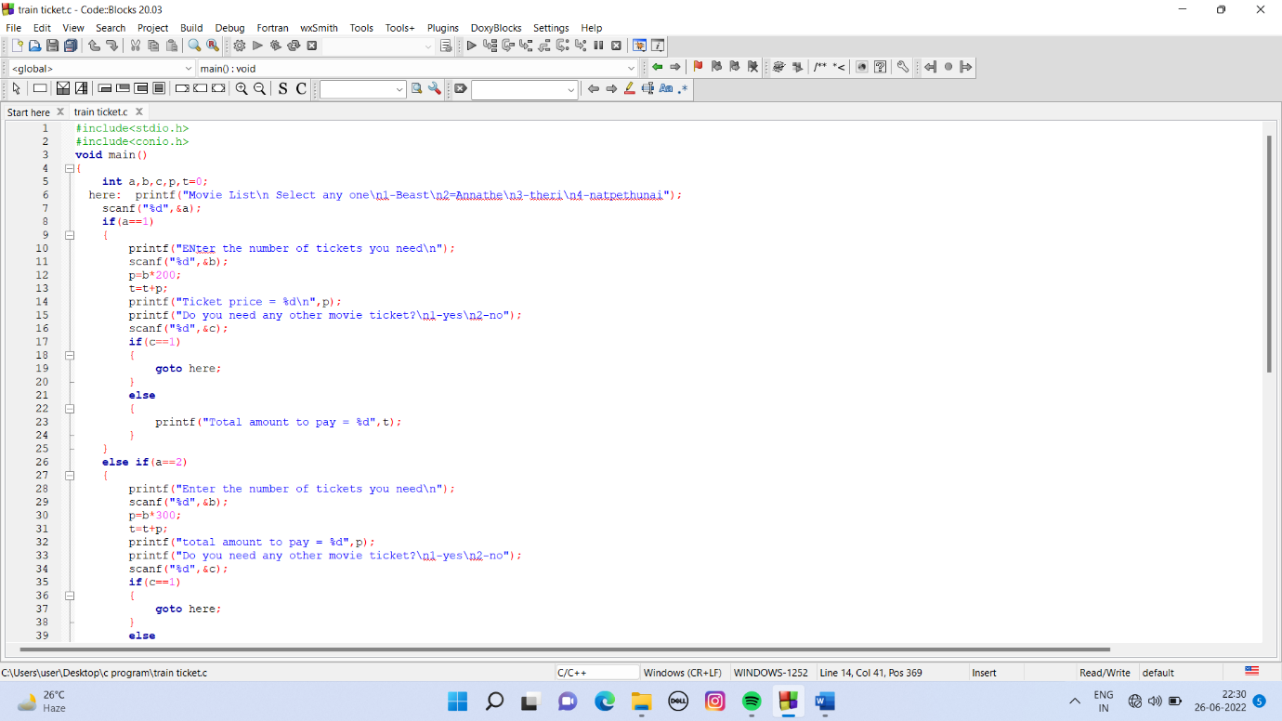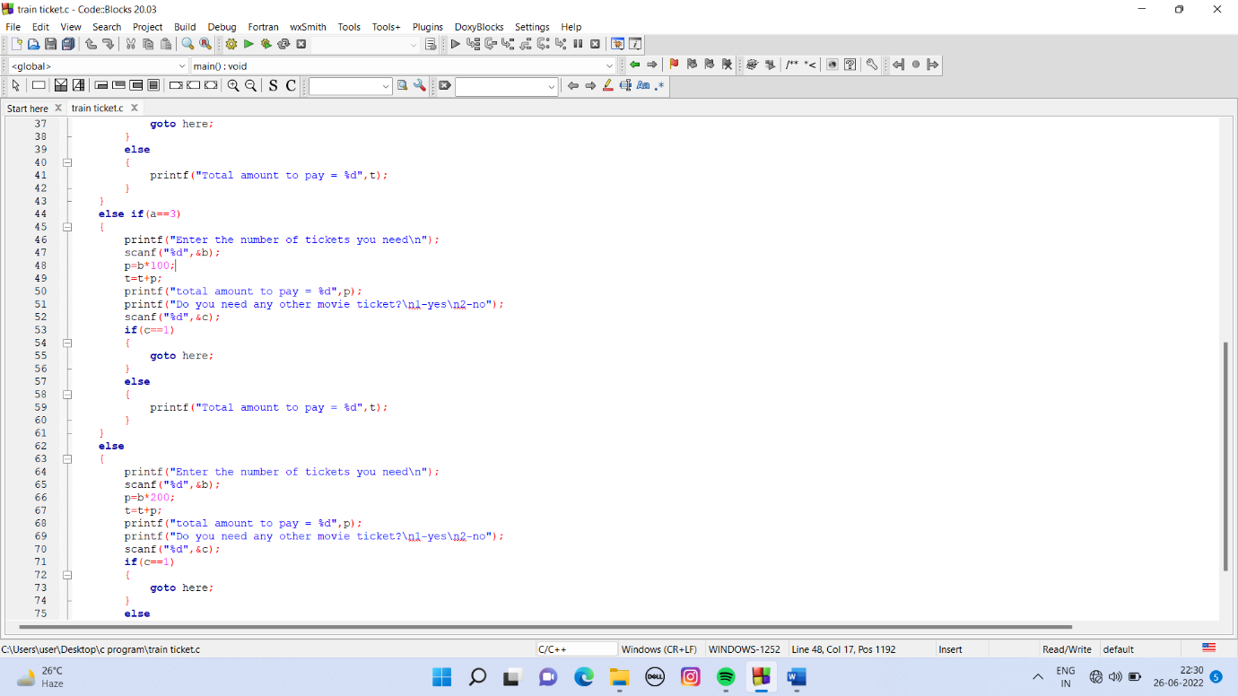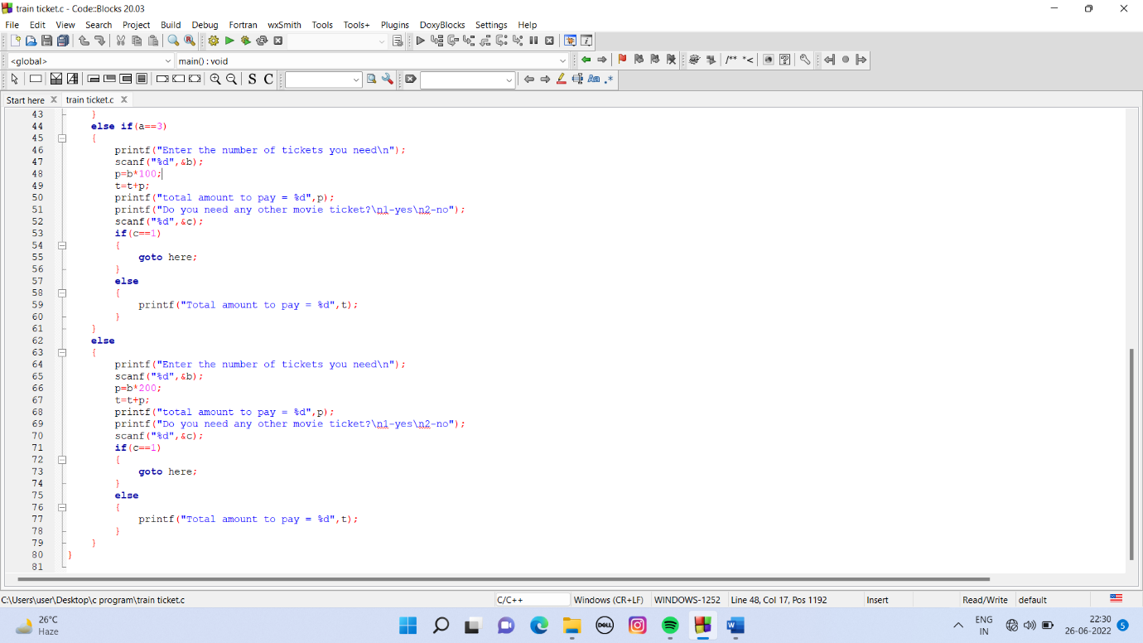

# OUTPUT

